INTERACT
Reducing plastic consumption and pollution
Authors: Marie Frost Arndal¹, Cornelya Klutsch² and Elmer Topp-Jørgensen¹
¹Arctic Research Center, Department of Ecoscience, Aarhus University, ²Nibio Svanhovd Research Station, Norway.

Further input: INTERACT Station Managers

Published 2023, First Edition
Graphic design: VplusN
Publisher: INTERACT
Cover photos: Front: ?????. Back: ?????.
Citation: INTERACT 2023. INTERACT Reducing plastic consumption and pollution.
Printed in Denmark 2023 by ????
ISBN: ?????
DOI: ?????
The book is available in PDF from the INTERACT website
www.eu-interact.org

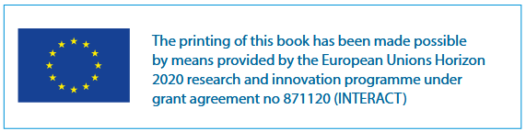

Contents
Preface 5
About this guidebook 6
1. Introduction to Plastic 7
1.1 What is plastic? 7
1.2 History of plastic production and waste generation 8
1.3 Bioplastics 10
1.4 Breakdown of plastics and degradation processes 12
1.5 Size classes of plastic 13
1.6 Handling of plastic waste 14
1.7 Plastic waste in the natural environment (sources and sinks) 16
2. Environmental impacts of plastics 17
2.1 Physical effects 17
2.2 Chemical effects 18
2.3 Plastic and climate change 19
3. International agreements and legislation 20
4. Guidelines for research station managers 22
4.1 Reduce use through purchase policy 22
4.2 Implement proper waste handling system at station 22
4.3 Influence staff and user behaviour 23
4.4 Housing, cleaning and kitchen utensils 23
4.4.1 Building materials and interiors 23
4.4.2 Cleaning 23
4.4.3 Kitchen utensils 23
5. General guidelines when working at research stations and in the field ………………………………………………………………………………..24
5.1 Field work 24
5.2 Clothes and washing 26
5.3 Personal care products 27
5.4 Laboratories 28
5.5 Green transition funding 29
6. Monitor plastic use, waste generation and pollution 29
6.1 Monitoring plastic use, waste and emissions at research stations 29
6.2 Monitoring plastic pollution in the environment 30
6.2.1 The role of citizen science and community-based monitoring (CBM) in plastic pollution research and monitoring 31
7. Influence local communities 34
8. A future outlook 35
References 39

Preface
Intro made by AMAP Plastic Expert Group

About this guidebook
The Arctic, alpine and boreal environments are unique and vulnerable ecosystems that are undergoing dramatic changes. Temperatures are increasing 3-4 times faster in the Arctic than elsewhere on the globe, alpine glaciers are disappearing at an alarming rate, species distributions are changing, environmental pollutants accumulate, sea ice is disappearing, etc. Plastic pollution and climate change share the same fossil origin: oil and gas. Plastic impacts climate change through the extraction of oil and gas for plastic, energy used in the transport, production, and waste handling phases (recycling and disposal), and plastic is a source of pollution impacting ecosystems through often unintended littering of e.g., macro- and microplastics. Plastics account for 3.4% of global greenhouse gas emissions (OECD, 2023a).

Plastics are now found in all environments all over the world, including in the Arctic, alpine and boreal environments e.g., on land, in water, in the seabed, in glaciers, and in the marine and terrestrial food chains.

We all have a share in the plastic pollution that is generated by all of us, and once it degrades into micro- or nanoparticles, they are virtually impossible to remove from the natural environment and could stay there for centuries to come.

This guidebook was made by managers of research stations to increase awareness of the problem and provide guidelines for how stations, scientists, and local communities can reduce negative impacts of plastic use and pollution.

The aim of this guide is to:
- Increase awareness of the impacts of plastic use on climate and the natural environment.
- Provide guidelines for how to manage plastics at research stations.
- Provide guidelines for how scientists can reduce negative impacts of plastics.
- Describe tools for monitoring plastic use and pollution, and how to increase awareness and engage local communities.

Introduction to Plastic
It is impossible for most people on the globe to go through a day without encountering plastics. What used to be made of wood, metal, paper, cotton, or leather are now often made of or contain plastics. The discovery of plastic was revolutionary and at that time human manufacturing was not constrained by limited natural resources and few were aware of the potential climate effects of fossil fuel use. The production of new materials was a huge benefit for many and today remains a vital resource in modern day society, e.g., health care, production industries, transport, agriculture and fisheries, telecommunications, clothing, packaging and storage, and everyday utensils. It was also regarded as being good for the natural environment as plastics could substitute natural and limited resources such as wood, metal, horn and ivory.

It was not until after World War II that plastic became more widely used. Polyester was introduced in the 1950s, and polypropylene, which is now one of the most used polymers in the world, was not available until 1954. Plastic began to replace the more expensive paper, glass, and metal materials, and today there are thousands of types of plastics serving different purposes.
It is now difficult to imagine a life without plastic. It is used for so many purposes and all around the globe, and we all have a share in the impacts it has on human health, the natural environment and climate.

What is plastic?
Plastic polymers can be synthesised by using carbon atoms from petroleum and fossil fuels. Different plastic types that are made from plastic polymers, have different characteristics. Most polymers are used in common consumer products in the form of polypropylene (PP), polyethylene (PE) and polystyrene (PS). Shopping bags are made from polyethylene, food containers from polystyrene, and drink bottles made by PET (polyethylene terephthalate, a form of polyester) (see Figure 1). A number of chemicals or additives, such as softeners (phthalates), fire-retardants, dyes, and sun filters, are added to make the plastic very sturdy or flexible – i.e., to make it plastic. There are more than 10,000 different chemicals known to be used as plastic additives throughout the manufacturing process (Hamilton et al., 2022).
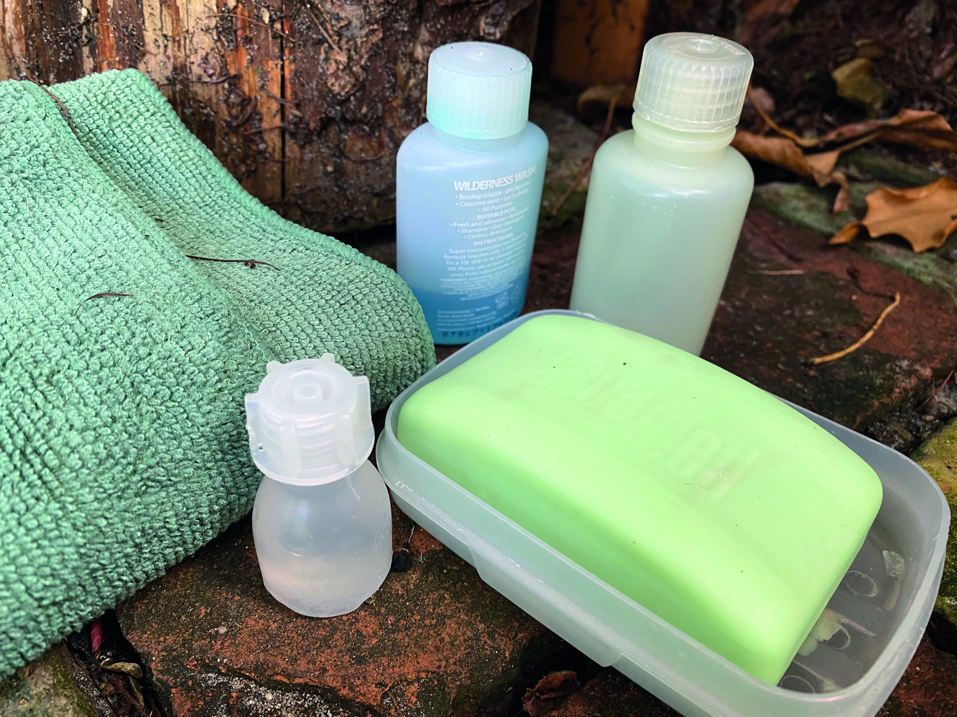
Plastics are used for many purposes at research stations e.g., personal care, kitchen, buildings and interior, laboratories, workshops, and cleaning products (Photos: Reynir Sveinsson and Josefine Lenz/Svenja Holste).

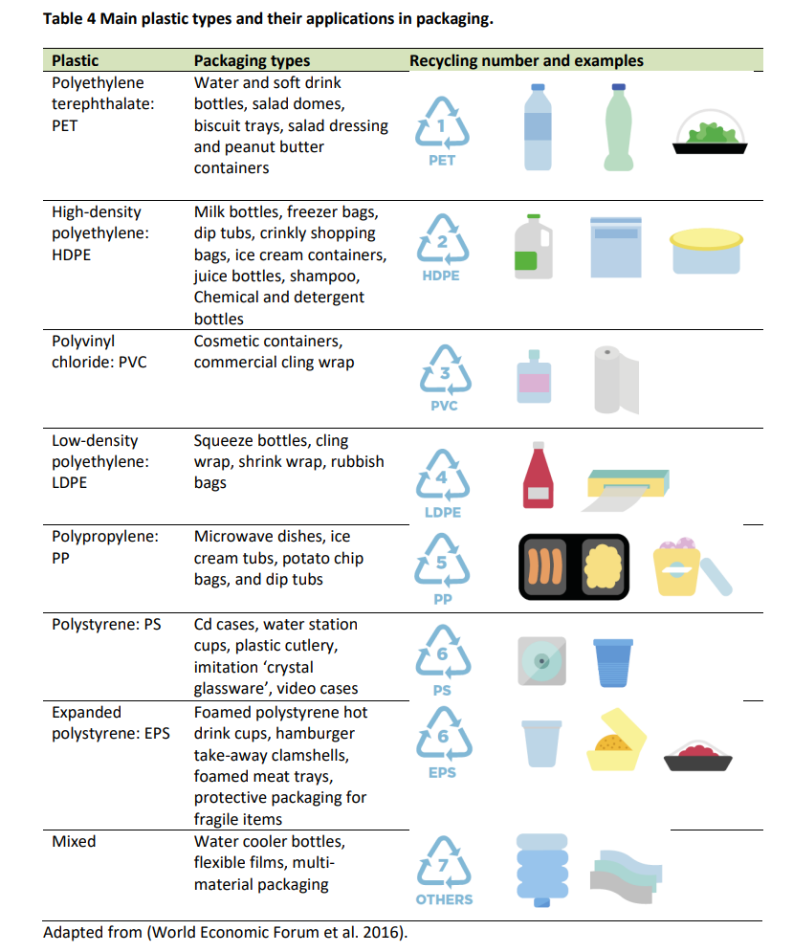

History of plastic production and waste generation
The total amount of plastic produced since its invention is estimated to 8,300 million tons (Mt) (Geyer et al., 2017). From 2000 to 2019 the global plastics production doubled to 353 million tons (OECD, 2023).

The unconcerned glory days of plastic are long gone, and the environmental concerns are building up. Climate impacts (of extraction, production, transport, recycling, and disposal), chemical components of certain plastics known to have environmental effects and health concerns, and the durability that have made plastic a success also means that it will stay in the environment for hundreds of years if not disposed of in the right way.

Single use plastics
Many plastic products are only designed for single use – or in other words, designed to be waste. As an example, the single use plastics, such as cotton bud sticks, cutlery, plates, straws, stirrers, balloon sticks, as well as cups, food and beverage containers made of expanded polystyrene. Recent examples include the COVID-19 pandemic which generated 1,600,000 tons/day of plastic waste globally (equal to the weight of 11,428 blue whales) mainly due to the increased production of disposable personal protective equipment and testing kits. To sustain this demand for personal protective equipment, many single-use plastic legislations were withdrawn or postponed. In addition, lockdowns and restrictions on public gathering all increased the dependency for online shopping and hence an increase in plastic packaging material.

There has been a steady increase in plastic production since the 1950’ies. There are some uncertainties about numbers, but OECD (2023) estimate that globally, only about 9% of plastic waste is recycled, 69% is incinerated, while 22% end up in the environment or in landfills. If current production and waste management trends continue, Geyer et al. (2017) estimate that roughly 12,000 million tons of plastic waste will be in landfills or in the natural environment by 2050 (Figure 2).

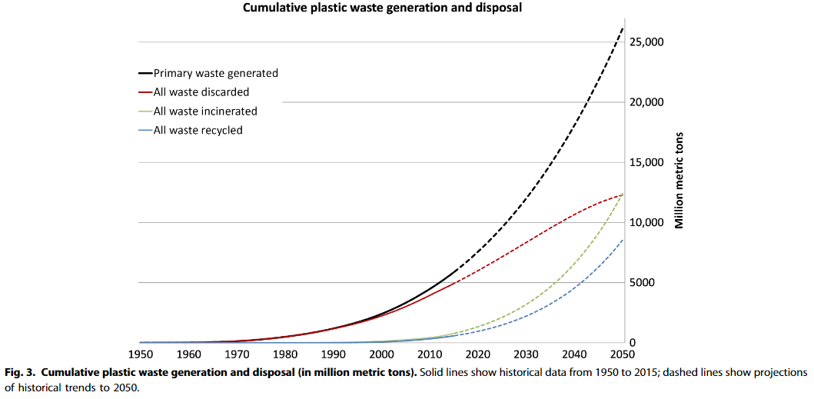
Figure 2. Cumulative plastic waste generation and disposal (in million tons). Solid lines show historical data from 1950 to 2015, dashed lines show projections of historical trends to 2050. (Geyer et al., 2017). 9 Mt of plastic waste will have been recycled.

With these huge numbers, billions of tons of material will accumulate across all major terrestrial and aquatic ecosystems on the planet, unless we develop a global management strategy for plastic very soon. The solutions require laws, regulations, management practices, and technology setting global standards for industrial production and design that maximises recycling, proper sorting, collection, recycling, and proper disposal practices at a global scale. Raising awareness enabling people to make the right choices when buying, using, sorting, and disposing plastic products. By developing such standards and practices we can ensure that products and materials are designed to be durable, reused, repaired, recycled or easily degradable.

Future circular economies include a drastic reduction in overall plastic consumption, design allowing products to be reused and recycled, improved energy efficiency in plastic and bioplastic manufacturing processes (use of renewable power), increased plastic waste collection rates and circular recycling and ‘upcycling’ methods (Rosenboom et al., 2022).

The current price of plastic products does not reflect the true cost of disposal and the cost of recycling or disposal. The ‘polluter pays’ principle hence needs to be included in the regulation of the plastic industry and products until the value of plastic waste as a resource becomes more viable in a circular economy.

Bioplastics
Bioplastics represent less than one percent of the plastic produced annually (bioplasticseurope.eu). Bioplastics are not just one single material. Bioplastics encompass a diverse range of materials that exhibit varied properties and serve different purposes. Bioplastic is biobased and/or biodegradable (Figure 3). Biobased plastics are made from plant or animal sources such as castor beans, soy, sugar cane, corn, potatoes, tapioca, wood fibres, shrimps, shells, etc. Through processing, the biomaterial is broken down into sugars that are changed through fermentation or chemical processes to form polymers. By adding resins to the polymers, manufacturers can create the type of plastic they need for a given project - these resins may be derived from plant sources or from petroleum products.

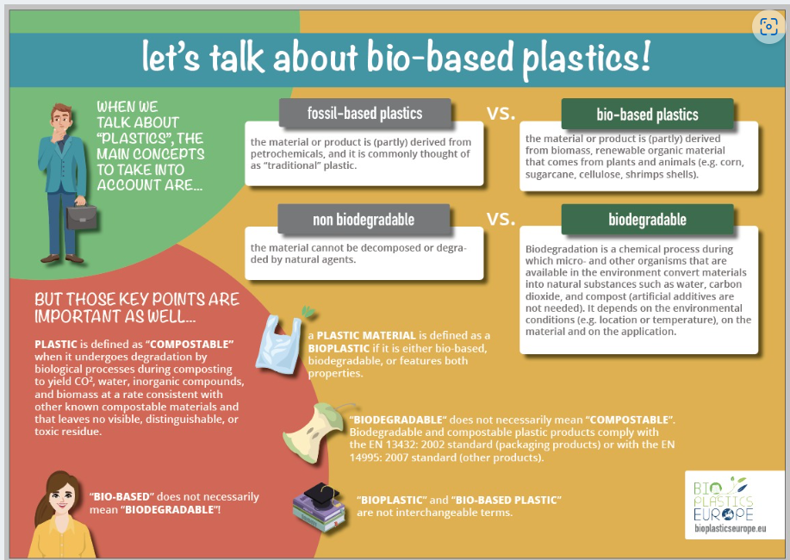
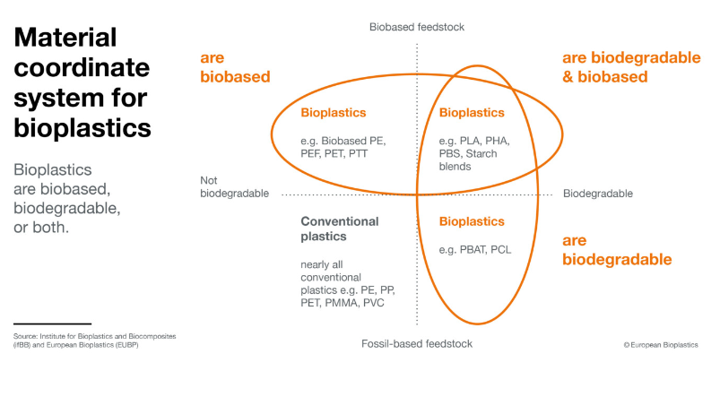

Figure 3. Characteristics of bioplastics (modified after Institute for Bioplastics and biocomposites and European Bioplastics (https://bioplasticseurope.eu/about, https://www.european-bioplastics.org/bioplastics/) – Layouter to redraw.

First-generation biomass uses crops and plants to produce bioplastics. This remains controversial, due to ethical concerns about the potential competition with food resources. Second-generation biomass uses various non-edible biowaste and is a more sustainable conversion of local, non-food, renewable resources, and biological wastes into bio-based plastics.

Bio-based plastics are not, by default, more sustainable than fossil-based plastics, as this is highly dependent on how the material is made, additives, where it is used and how it can be recycled. As the largest carbon footprint of plastics is associated with production, switching existing processes to a renewable energy supply would cut plastic-related emissions by 62% (Rosenboom et al., 2022). Further, not all bioplastics are biodegradable. Biodegradable plastic can be broken down completely into water, carbon dioxide and compost by microorganisms under the right conditions. Biodegradable or compostable bioplastic waste often requires processing under controlled conditions (i.e., at industrial level) to be incorporated back into nature, hence biodegradable plastics often need to be handled by proper treatment facilities. Some residues generate the same pollution problems as those derived from petroleum because they also produce micro- and nanoplastics during their decomposition.

Breakdown of plastics and degradation processes
Most plastic types do not decompose. Instead, plastic items will break down over time into smaller and smaller particles through mechanical abrasion, hydrolysis, or photodegradation through UV from sunlight. Fragmentation and weathering may proceed until the nanoscale (i.e., 0.000001 mm). Degradation rates are slow and especially so under cold arctic or alpine temperatures. Also, at the bottom of the sea, the breakdown of plastic can happen more slowly due to cold temperatures and lack of sunlight. Half-lives range up to 1,200 years for tubes (Koelmans et al., 2022), meaning that it often takes hundreds to thousands of years for the plastic pieces to reach nanoscale (Figure 4).

This results in an accumulation of plastic pollution as more and more ends up in the environment.

Plastic degradation processes
Mechanical abrasion: is a tactile process of scuffing, scratching, wearing down, marring, or rubbing.
Hydrolysis: is any chemical reaction in which a molecule of water breaks one or more chemical bonds.
Photodegradation: is degradation of a photodegradable molecule caused by the absorption of photons, particularly those wavelengths found in sunlight, such as infrared radiation, visible light, and ultraviolet light.
Biodegradation: is the process by which microorganisms break down organic matter.

Figure 4. Decomposition time of selected plastic products (Aguilar, 2018).

Size classes of plastic
Plastic pollution comes in many different sizes, and each size class has different environmental effects. Here we describe particle sizes used by the Arctic Monitoring and Assessment Program under the Arctic Council: macro-, micro-, and nanoparticles (AMAP, 2021).

Macroplastic is generally defined as plastic items larger than 5mm, e.g., bottles, bags, straws, string/fishing net, shotgun shells, buckets, or pieces thereof. It can impact individual animals through e.g., entanglement, ingestion (blocking or accumulating in stomach), suffocation (blocking airways). Many of us have seen plastic waste washed ashore on beaches and many have seen photos of wildlife entangled in or suffocated by plastic, and stomachs full of plastic.
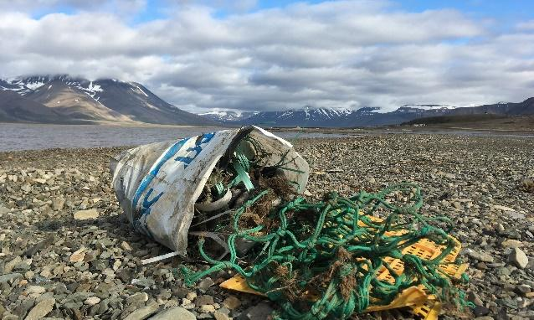
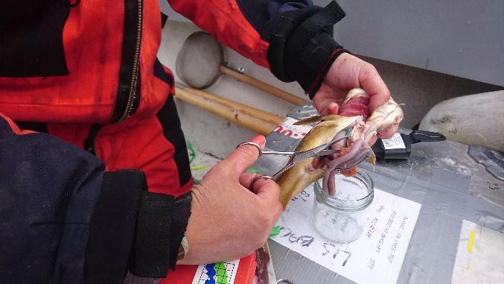
Macroplastics can be found on beaches and in the stomachs of animals even if they are far from densely populated areas (Photos: Maria Granberg).

Macroplastic waste also has a significant economic implication for a range of marine industries, e.g., aquaculture, fisheries, harbours, industrial seawater users, marinas, municipalities, power stations, rescue services, shipping, and water authorities. These include costs related to e.g., cleaning, blockages, entanglement, and contamination. Marine litter can also be a possible vector for the transfer of alien species, such as bryozoans, barnacles and polychaete worms. Litter also impacts people’s quality of life by loss of aesthetic value and reduced recreational opportunities.

Microplastics are generally defined as less than 5mm and come in different shapes, e.g., spheres, fragments, granules, pellets, flakes, beads, filaments, and fibres. Microplastics are primarily a concern due to their small size, which means easy ingestion in marine life and in food chains (see chapter 2 on physiological effects).

Primary microplastics are plastic pieces produced in that size, e.g., nurdles (building blocks of most plastic products), cosmetic microbeads (used in lotion, hair products, toothpaste, etc.), while secondary microplastics come from the degradation of larger plastic objects. The vast majority of microplastics come from the breakdown of larger plastic waste.

Nanoplastics are generally defined as < 1 µm but the identification of nanoplastic particles is still challenged by technical detection capabilities. Under laboratory conditions, a plastic particle of 1 mm in diameter would require about 320 years to reach a nanoscale diameter of 100 nm, but in the environment, degradation can be assumed to be faster (Koelmans et al., 2022). The actual amounts and characteristics of nanoplastic particles in the environment remain largely unknown (Koelmans et al., 2022 and references herein).

Handling of plastic waste
Ideally, plastics should never be waste, but be part of a circular economy where plastics are reused or recycled (Davidson et al., 2021). Currently, however, around 40 percent of plastic products are garbage after less than a month and it is estimated that only 9% of plastic waste has been recycled since 2015 (Geyer et al., 2017). The majority of the waste has been disposed of in landfills.

There are essentially three different fates for plastic waste (Geyer et al., 2017):
- It can be recycled or reprocessed into a secondary material. Contamination and the mixing of polymer types generate secondary plastics of lower technical and economic value.
- Plastics can be incinerated.
- Plastics can be discarded and either contained in a managed system, such as sanitary landfills, or left uncontained in open dumps or in the natural environment.

The most used waste disposal mechanism is landfills (50%), followed by incineration (19%) (burning plastic trash to create energy), and 22% evades waste management systems and goes into uncontrolled dumpsites, is burned in open pits, or ends up in terrestrial or aquatic environments, especially in poorer countries (OECD, 2023).

A landfill can, in theory, act as a carbon sink if there are no leakages. This will require that CO₂ and other greenhouse gases emitted from decomposition processes are captured. However, landfills often leak and spread to the environment. Plastic in the landfill is lost from the value chain in a circular economy and a continued demand for plastic necessitates additional extraction of fossil fuels for the production.

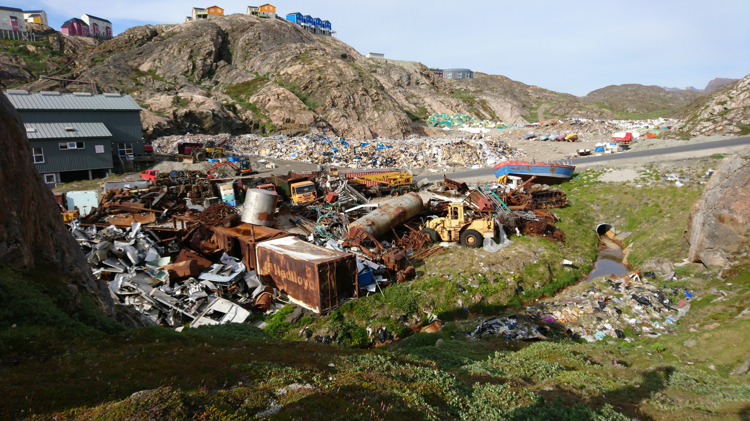
Landfills are widely used for disposal of plastic waste and receive close to half of all global plastic waste (Photo: Maria Granberg).

When burning plastic, you also remove plastic from the value chain and the burning of plastic waste produces other harmful pollutants, such as dioxins, metal compounds, and greenhouse gases. Thus, incineration should take place in proper treatment plants that remove harmful substances from emissions. Furthermore, there are concerns of a ‘locking-in’ effect, whereby the high investment cost for incineration plants and the need for constant waste influx may jeopardize the adoption of recycling technologies (Rosenboom et al 2022).

One of the biggest barriers to plastic recycling is separation: when different polymers are mixed, the resulting material does not usually have useful properties. Plastic and bioplastic recycling is generally complicated by the presence of additives in almost every finished plastic product.
It is possible to recycle plastic back into oil and then to other useful products like fuel (or other types of plastic). The main problem is that it requires a lot of energy. It should not take more energy to recycle plastic than you’re saving by recycling it.

Biodegradable/bio-based plastics are considered to be plastic under the EU’s Single Use Plastic Directive (https://eur-lex.europa.eu/eli/dir/2019/904/oj). In accordance with the EU standard EN 13432, a product is classified as compostable if it satisfies specific requirements, including the following criteria when subjected to industrial composting facility conditions (from www.bioplasticseurope.eu ):
- At least 90% biodegradation into CO₂ within 6 months
- No more than 1% additives, which must be harmless (non-toxic and no negative effects on plant growth)

Plastic waste in the natural environment (sources and sinks)
Plastic pollution can be transported to the Arctic and alpine environments from far away via wet (ocean currents, rivers, rain) or dry (air) deposition, or waste emissions by industry and humans (tourists, researchers, locals).

Surface circulation models and field data showed that the poleward branch of the Thermohaline Circulation transfers floating debris from the North Atlantic to the Greenland and Barents seas, which would be a dead end for the plastic waste. Given the limited surface transport of the plastic that accumulated here and the mechanisms acting for the downward transport, the seafloor beneath this Arctic sector is hypothesised as an important sink of plastic debris (Cózar et al., 2017). Scientists believe that 80% of the plastic in the aquatic environment ends on the ocean floor. In the Arctic deep sea, microplastic concentrations range between 0 and 16,041 particles kg⁻¹ sediment and rank amongst the highest measured concentrations globally (Bergmann et al., 2022).

Plastic pollution of the terrestrial soils can be between 4 and 23 times higher than in the seas, depending on the environment. Especially sewage (domestic wastewater) is an important factor in the distribution of microplastics where sewage sludge is applied to fields as fertiliser on agricultural fields.

Wastewater treatment is often lacking in the Arctic and other remote locations. In some communities, traditional waste management solutions are direct emission to the sea/water ways, and landfills, sometimes next to the sea. This means that plastic litter and microplastics more easily reach the environment and enter the ocean.

When we wash synthetic fabrics and clothing, like polyester, fleece, or jackets in washing machines, the clothing sheds tiny plastic fibres. It is shown that microfibre fleeces are the most commonly detected type of fragments in various water bodies (Mishra et al., 2017).

Most of the primary microplastics waste (98%) is generated from land-based activities. Textile fibres and particles from car tire abrasion are the two main sources of primary microplastic in the ocean. The main pathways of these plastics into the ocean are through road runoff (66%), wastewater treatment systems (25%), and wind transfer (7%) (iucn.org). The International Union for Conservation of Nature (IUCN) (Boucher and Friot, 2017) divides the global contribution of different primary sources of microplastics into the marine environment into seven categories:
- Synthetic textiles.
- Vehicle tyres.
- Road markings.
- Personal care products and cosmetics.
- Plastic pellets.
- Marine coatings.
- City dust (a group of nine sources, including losses from the abrasion of objects and infrastructure, and abrasive blasting of surfaces with sands sized particles).

Environmental impacts of plastics
Plastic is present all around the globe in all size classes. Micro- and nanoplastics are present in air, water, and ice. It is ingested by animals, including commercially important species of fish and shellfish eaten by humans. There is also evidence that micro- and nanoplastics can be found in internal organs of humans (e.g., lungs, livers, spleens, and kidneys). However, the environmental impact and health risk associated with human consumption are not yet well known (Koelmans et al., 2022). There is, however, substantial evidence that plastics-associated chemicals, such as methyl mercury, plasticisers, and flame retardants, can enter the body and are linked to health concerns (https://www.unep.org/interactives/beat-plastic-pollution/). Therefore, there is a clear need for improved understanding of the effects of plastic pollution and vector borne chemicals on ecosystems, species, and human health.

Physical effects
Some effects of plastic waste in the environment are obvious to see, while others are less visible. For macroplastic, wildlife and fish can get entangled in plastic (get stuck or suffocate), eat plastic that fills up or block their digestive systems, or have their airways blocked or gills destroyed by plastic pieces. The visible impact caused by macroplastic to larger animals, is well documented (AMAP Plastic Monitoring Plan recommend Northern fulmar (bird) as one of 11 plastic monitoring compartments).

On the other hand, very little is known about what micro- and nanoplastics can do to the ocean's smallest organisms such as zooplankton, fish larvae, and clams. It has been suggested that smaller particles are potentially more hazardous if ingested but it may also be that very small particles in the nano size range may pass into and out of organisms with relative ease (Sapea, 2019). Microplastics often pass through the digestive systems of living organisms, and as with many chemicals ‘the poison is in the dose’ – meaning that it is the number (and size) of particles that pose a threat and the possible chemicals attached to it (Sapea, 2019). Microplastics may also adhere to smaller organisms restricting their movements and hence their ability to find food (https://www.unep.org/interactives/beat-plastic-pollution/).

The microscopic sizes mean that it is almost impossible to filtrate for micro- and nanoplastics without impacting smaller ocean organisms and animals in the ocean. More work is needed to understand the differential retention and effects of particle size.

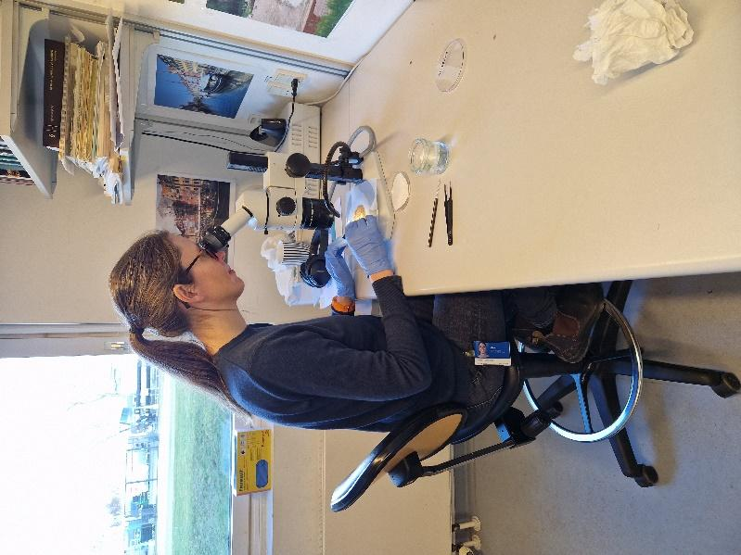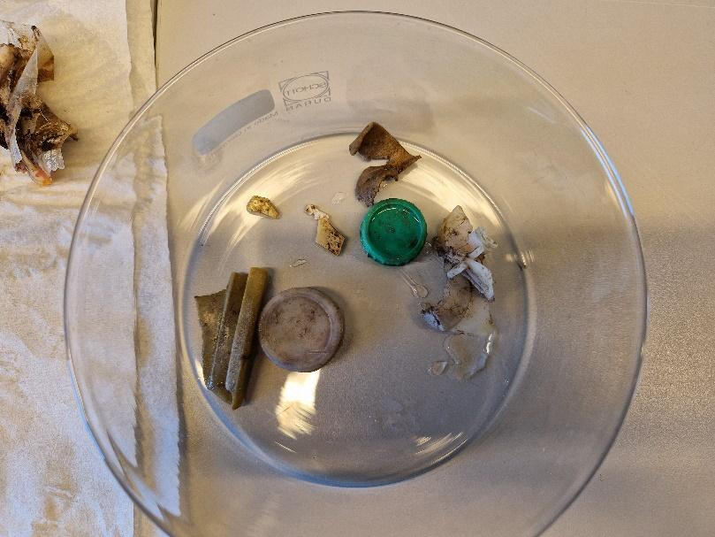
Plastic debris from the stomach of a Northern fulmar (Photos: Marie F. Arndal).

Chemical effects
The role of chemical adherence to or release from plastic particles is of particular concern in the Arctic because of the dependency on subsistence harvesting of natural resources. Monitoring of chemical contaminants in the Arctic has been conducted for several decades through AMAP.

It has been hypothesised that release of chemicals from microplastic after particle ingestion increase exposure to these chemicals, and subsequently results in chemical risks to biota (the ‘microplastic vector effect’). Newer studies suggest that this effect is unlikely to play a major role (Koelmans et al., 2022), also as concentrations of toxins at sea remain very low (Flint et al., 2012). There may, however, be a need to evaluate the behaviour of plastic additives under Arctic and alpine conditions as the migration of chemicals (e.g., leaching, adsorption/desorption) is slower in colder regions (Hamilton, 2022).

The effects of nanoplastics are even more uncertain than microplastics, due to lack of studies on their behaviour in the environment. Currently limited or no data are available for nanoplastics in food, and toxicity data are lacking for both micro- and nanoplastics (EFSA, 2016). As the distribution and concentrations of nanoplastics in the environment remains largely unknown, we do not know enough about the role of nanoplastics for the total chemical risks posed by fragmenting microplastics (Koelmans et al., 2015).

Neither do we know much about the effects of small plastic particles can have on humans. What we do know, however, is that there are chemicals in plastic, such as Bisphenol A (BPA) and phthalates, which can have harmful effects on humans. The plasticizers phthalates can easily leach out or evaporate as they are not chemically bound in the materials they are added to. People are exposed to phthalates by handling or coming into contact with items stored in such plastic types (e.g., eating and drinking foods that have been in contact with products containing phthalates). Phthalates are frequently used in raincoats, sports clothing and even children's toys. It is scientifically known that it has harmful effects on the human body including e.g., earlier onset of puberty, reduced male reproductive system development, impaired hormone system function, reproductive and genital defects (Mishra et al., 2019).

BPA is used primarily in the production of polycarbonate plastics and can damage female reproductive hormones. The BPA in food packaging materials is now regulated more strictly in many countries, especially in infant feeding bottles. The general 'background exposure' to BPA through, e.g., other foods and food packaging is 40 million times higher than from eating blue mussels that may contain microplastics (Rist et al., 2018). This means that the number of blue mussels one eats with associated microplastics is completely insignificant compared to one's exposure to BPA through other sources. What should be in focus is our total exposure to plastics and microplastics in our everyday lives.

To fully understand the chemical effects of micro- and nanoplastics, we need an improved understanding of chemical properties of different plastic types, and their distribution and concentration in the natural environment, to the volatility of chemical compounds and their effect on ecosystems, species, and humans (including their role in cumulative effects).

AMAP provides recommendations for monitoring of plastic and chemical additives, including persistent organic pollutants (POPs), and are currently developing monitoring recommendations for emerging pollutants (new chemical compounds used by the industry). Further standardisation of sampling and detection methods, health effect studies, etc. is key to fully understand the scale of impact of chemicals associated with micro- and nanoplastics.

Plastic and climate change
Since the modern plastics industry relies on fossil fuels for its raw material, transport, manufacturing processes, recycling, or treatment of plastic waste (incineration), the production of plastic has an impact on climate change, contributing to global CO₂ production. Currently, a total of 6% of the global raw oil extraction is used for plastic production (World Economic Forum, 2016). This number does not include the oil that is used afterwards in transportation, processing, handling, etc. or the CO₂ emitted when the plastic is degraded. Furthermore, greenhouse gases such as methane, ethylene, ethane, and propylene are released during degradation of some common plastic polymers throughout their lifetime (Royer et al., 2018).

When darker particles are deposited on snow and ice (can be emitted on site or smaller particles transported by air), they affect the ice-albedo feedback, by reducing the ability of snow and ice to reflect the sunlight resulting in increasing melting of the snow and ice (Geilfus et al., 2019). In the atmosphere, microplastic particles can serve as condensation nuclei for water vapour, producing effects on cloud formation and hence the climate.

International agreements and legislation
Legislation addressing plastic pollution can mainly be grouped into measures that aim to protect the environment and those that are focused on waste (Sapea, 2019). There is a broad range of international, national, regional, and local policies and legislation concerning plastic production and waste handling, but policies are implemented inconsistently across regions. To reduce plastic pollution, international collaboration is needed to implement standardised policies (legislation and management practices) and long-term monitoring programs (Linnebjerg et al., 2021).

In 2022, UN Member States endorsed a resolution to end plastic pollution and forge an international legally binding agreement by 2024 ref. The resolution addresses the full lifecycle of plastic, including its production, design, and disposal.

The AMAP Regional Action Plan on Marine Litter (2021) will enable the Arctic Council to take targeted and collective action to address problems with marine litter in the Arctic. The overall objective of the Regional Action Plan is to “support Arctic States’ efforts to reduce marine litter in the Arctic marine environment, prevent the potential negative impacts and mitigate the risks it may pose, and to improve cooperation on and awareness of this shared objective”. The plan is not legally binding and relies on national implementation of its actions that addresses both activities in the sea and on land, outlining strategic actions within eight thematic areas. Until the completion of the Arctic Council Regional Action Plan on Marine Litter, there is no pan-Arctic framework to address plastic pollution (Linnebjerg et al., 2021).

EU adopted a European strategy for plastics in January 2018 that aims to reduce marine litter. It is now part of EU’s circular economy action plan (CEAP, 2020), which builds on existing measures to reduce plastic waste. The “Directive on the reduction of the impact of certain plastic products on the environment” (commonly referred to as the Single-Use Plastics (SUP) Directive) entered into force in 2019. It aims to tackle pollution from single-use plastics (and fishing gear), as the items most commonly found on European beaches. From 2022, Member States will be obliged to report on fishing gear containing plastic placed on the market and fishing gear recovered at sea.

EU’s circular economy action plan aims to e.g., make sustainable products the norm in EU and ensure less waste. A central initiative of the plan is also to improve the science on the distribution of microplastics in the environment, tap water, and food, and how to reduce environmental pollution and potential health risks. EU also seeks to tighten rules on pollutants other than CO₂ from vehicles (Euro 7) that will set additional limits for particulate emissions from brakes and microplastic emissions from tyres (effective from July 1, 2025, https://ec.europa.eu/commission/presscorner/detail/en/ip_22_6495).

Some business sectors also work to reduce their use and disposal of plastics. The tourist industry is contributing to the large amount of plastic waste in our environment. The Global Tourism Plastics Initiative (https://www.unwto.org/sustainable-development/global-tourism-plastics-initiative) aims to reduce plastic pollution through an agreement to be developed by 2025. Their commitments include elimination of unnecessary single-use plastics, transition to reuse models and use of reusable, recyclable, or compostable plastic packaging and items. The Association of Arctic Expedition Cruise Operators (AECO) is working to combat marine plastic pollution by sharing of best practices and lists of alternative products (which AECO is currently developing) with its operators.

The scale, distribution and amounts, and effect of plastic waste ending up in the environment necessitates continued development and implementation of international standards for plastic production governance and waste handling practices to ensure a circular economy for plastics and prevent negative climate, environmental, and health impacts.

Guidelines for research station managers
Plastics are used for many purposes at research stations, e.g., research instruments, laboratories, containers, packaging, clothing, and vehicles. They have many useful properties being e.g., lightweight, durable, easily cleaned/sterilised, and cheap. However, some plastic products are made for single use (or short-term use) and some easily degrade or shed microfibres wherever they are used. So, while plastic can be sturdy and have long durability, large amounts of plastic end up in the environment as litter (macro- to nanoscale) or as waste that needs proper treatment or disposal.

Reducing the use of plastic is a first step towards reducing plastic waste generation and pollution. For this, research stations need to consider durability of plastic products, reuse and recycling potentials and alternative products in purchase policies. Secondly, research stations should develop plastic use policies, and implement proper waste management systems to limit emissions to the environment including sorting procedures and proper disposal mechanisms with minimal impacts on the natural environment and human health. Furthermore, research stations can also play a role in monitoring plastic pollution and guiding behaviour of staff, visiting scientists, and local communities.

Research stations can and should therefore work with plastics on several levels, e.g., internal policies, scientific monitoring of local environmental problems associated with plastics and influencing human behaviour.

Reduce use through purchase policy
An efficient way of minimising plastic use at a research station is to develop a purchase policy that can guide station management and staff in relation to buying plastic products or products containing plastics.

A purchase policy may prioritise:
- Sturdy and durable plastic products.
- Products with no harmful chemicals.
- Reusable or repurposed plastic products.
- Recyclable plastic products.
- Alternative products with no plastic where possible. Re-use products for same or other purposes
- Re-use plastic containers for other purposes.
- Reuse packaging materials (or return to supplier).

Implement proper waste handling system at station
- Collect, sort and store plastic waste in relevant fractions for reuse, recycling, or disposal.
- Submit recyclable and disposable plastic to municipal treatment system (if these follow good environmental practices) or transport to proper treatment facility.
- Treatment on site should only be done if you have proper treatment equipment (e.g., incinerator that burns at required high temperatures, minimum 850C).
- Put filters on outlets to rivers, oceans, etc. to collect microplastic.

Influence staff and user behaviour
- Develop rules and guidelines for staff and visitors related to:
  - Allowed/prohibited use of certain products, e.g., easily degradable plastics and products containing microplastics.
  - Expected behaviour, including collection, sorting and disposing of plastic products.
- Offer certified environmental cleaning agents, toothpaste, etc. that do not contain plastics or environmental pollutants. In this way, stations can ensure that no harmful substances are emitted.

Housing, cleaning, and kitchen utensils
Building materials, interiors, and utensils may all include plastics. This is not necessarily a problem; it all depends on the types of plastic and the degradation processes it is subjected to. The important thing is that it is durable, sturdy, free of harmful chemicals, reusable, and recyclable.

4.4.1 Building materials and interiors
- Exposed building materials prone to degradation (e.g., from weather and sun light) should, if possible, be durable and long-lasting non-plastic (end environmentally friendly) based materials.
- If using plastic products in the interior building design, prioritise plastic products and types that can be reused or recycled.
- Furniture, carpets etc. should preferably be made from natural fabrics (e.g., wool, textiles, sisal) to avoid accumulation of plastic particles in indoor air and house dust).
- Use plastic free interior and exterior building paints.

4.4.2 Cleaning
Cleaning tools, cloths and detergents may be made of or contain plastics. While sturdy reusable tools may not degrade easily, the use of synthetic cloths and sponges, and detergent containing plastics will add microplastic to the wastewater.

Recommendations:
- Buy durable plastic cleaning equipment that can be reused and recycled.
- Use reusable natural scrubbers instead of plastic scrubbers and synthetic sponges (e.g., Loofah scrubbers).
- Consider cleaning tablets instead of liquid soap, shampoo, bodywash, and cleaning detergents – this reduces transported volumes and reduces CO₂ emissions.
- Use detergents without plastic components.
- Use natural, reusable, and washable cotton cloths or flannels for washing up and cleaning rather than disposable cleaning cloths or microfibre cloths.

4.4.3 Kitchen utensils
- Use environmentally friendly alternatives to plastic where possible, e.g.:
  - Store food in glass, metal or sturdy reusable and recyclable plastic containers.
  - Glass containers to microwave food.
  - Drink tap water out of a glass (where safe to do so).
  - Use matches instead of disposable plastic lighters or invest in a refillable metal lighter.
  - Use a chopping board made of wood or marble instead of plastic to avoid microplastic in the food when chopping vegetables etc.
- Avoid single use plastics, e.g.:
  - Reduce takeaway cups of plastic or with plastic coating.
  - Avoid plastic cutlery – use metal or wooden cutlery.
  - Avoid using plastic bags.
  - Do not use plastic straws.
  - Avoid excessive food packaging in plastic.
  - Use reusable bags for shopping. Have some non-plastic bags or bag packs at the station that visitors can use to do their shopping.
- Buy loose tea and use a tea egg or a teapot filter, as many tea bags contain plastic (many tea brands and supermarkets use a plastic called polypropylene to seal their teabags).

General guidelines on how to manage plastic when working at research stations and in the field

The ‘INTERACT 7R principles’ for reducing plastic use and pollution:
- Refrain from using unnecessary, harmful, low quality and un-recycleable plastics
- Replace plastics with sustainable alternatives
- Reduce use of plastics where possible
- Repair
- Reuse for same or other purposes
- Recycle by ensuring proper sorting and disposal
- React - speak up to influence friends, family, colleagues, institutions, and politicians

While stations can influence user behaviour through rules and guidelines, individual scientists can also take responsibility for minimising use of plastics and stopping emissions to the natural environment.

Below are inspirational recommendations related to:
- Field work
- Clothes and washing
- Personal care products
- Laboratories

Field work
Make sure not to contribute to the plastic pollution in the environment by using only sturdy, durable and recyclable plastic for your fieldwork. Plastic markers can easily be broken down or destroyed by the harsh weather in the Arctic or by curious animals. Plastic pollution left behind from researchers will stay in the ecosystems for many years.

Recommendations
- Do not litter.
- Bring a refillable water bottle to avoid single use bottles.
- Bring a lunch box and food paper/beeswax cloth, instead of packing food in plastic bags, foil, or food wrap/cling wrap.
- If needing to use plastic, prioritise sturdy, durable, and environmentally friendly plastic that does not deteriorate and spread to the environment.
- When possible, consider alternatives to plastic, e.g., using metal or wood sticks and pegs for plot identification.
- Duct tape – will not last in the field during the arctic winter! Do not leave it in the field for longer periods and bring it back for proper sorting.
- When using plastic in the field (plastic chambers or tents), make sure that it does not blow away during a storm or spread to the environment.

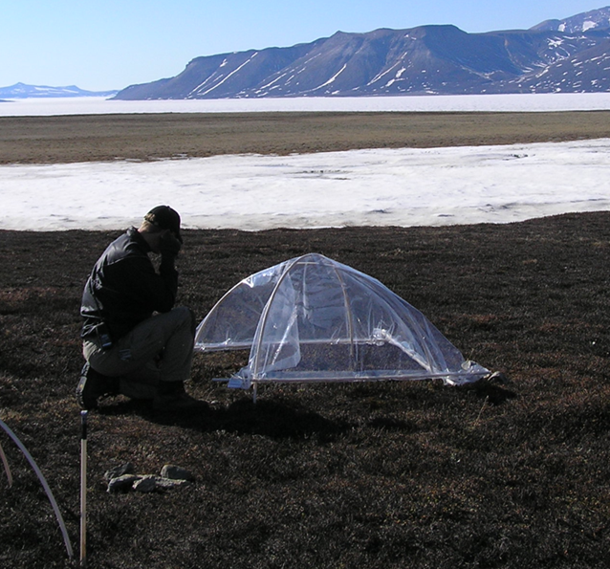
Plastic tent used for field manipulation studies (Photo: Marie Frost Arndal).

5.2 Clothes and washing
In the Arctic, much of our modern winter clothes are made from artificial fibres, like fleece. Fleece is commonly made of polyester, and polyester is a synthetic fabric, which means fleece releases microplastics. These synthetic fabrics provide numerous benefits: they are lightweight, quick drying, highly insulating, and remarkably resistant to wear. But those benefits come at a cost to the natural environment.

The most likely origin of this released polyester is laundry. More than one-third of the microplastics in the ocean originates from synthetic clothing. A recent study (Ross et al., 2021) found that 73% of synthetic fibres found in the Arctic were polyester. The powerful currents and winds out on the open sea make it difficult for even advanced technology to clean it, once it is in the aquatic environment. Clothes pollute more the first few times we wash them, so consider buying less new clothing and keep your old for as long as possible. Never buy very cheap fleece products, as the fibres of these are extra vulnerable. Garments of a higher quality shed less in the wash than low-quality synthetic products, illustrating the importance for manufacturers and consumers alike to invest in gear built to last.

Studies show synthetic jackets laundered in top-load washing machines shed approximately seven times as many microfibres as the same jacket in front-load washers. Putting your synthetic clothing into a filter bag before washing by hand or machine can significantly reduce the flow of microfibres into your drain. Several types of laundry filter devices have been developed, including those that are built into the washing machine, those that can be retrofitted into older machines, and devices that are placed in the drum of the machine during the laundry cycle.

Recommendations on clothes and washing
- Buy natural fabrics (wool, cotton, silk, linen, cashmere), or environmentally certified clothing (https://alwaystheadventure.com/sustainability/sustainable-outdoor-clothing-brands).
- Remove single stains on the fleece by hand, instead of using a washing machine.
- Use a front-loaded washing machine equipped with filters or use a microplastic washing bag when washing synthetic materials (e.g., acrylic, nylon, and polyester).
- Fill up your washing machine – a full load results in less friction between the clothes and less fibres will be released.
- Use washing liquid instead of powder – the powder will, through the ‘scrub’ function, loosen the fibres of the clothes.
- Wash at lower temperatures – some fabrics will be damaged in high temperatures and result in looser fibres.
- Avoid long washing cycles that will cause more friction of the clothes and more fibres released. Dry spin at low to decrease the friction of clothes.
- Air dry clothes where possible (which also saves energy) and use wooden clothespins.
- Consider donating old fleece, as well as other old clothing, if in good quality. If you donate your old fleece, you prevent other people from buying new ones.

5.3 Personal care products
Losses from personal care products are the only losses that can be considered as intentional losses, where the product containing microplastics is poured into wastewater on purpose. This could be in products like facial and body scrubs, sunscreen, lotion, or toothpaste. An IUCN report estimates that personal care products make up 2% of total primary microplastics entering the global marine environment (Boucher and Friot, 2017). Unfortunately, there do not appear to be widely accepted, naturally occurring alternatives for the polymers in PCPs and cosmetics performing functions, beyond exfoliation.

Several apps can help you scan products for plastic, e.g., ‘Beat the microbead’, where you can find out if your personal care products contain microplastics.

Furthermore, female hygiene products like tampons, tampon applicators, and pads, are the fifth largest contributor to plastic pollution along the coastline of Europe (European Parliament, 2021, Snekkevik et al., 2023). It is estimated that up to 45 billion disposable menstrual hygiene products are used and disposed of each year (Barth 2021). The production of these products is estimated to account for approximately 245,000 tonnes of CO₂ emissions/year (Cabrera and Garcia, 2019). An additional problem is that these products are not properly discarded, which may lead to problems in treatment plants (Norsk Vann, 2021), including economical costs.

Based on a meta-analysis from the United Nations Environment Program (UNEP, 2021), it was concluded that reusable menstrual cups had a significantly lower environmental impact than a disposable option. Other options include menstruation underwear, and reusable/washable pads (Snekkevik et al., 2023). Since one of the problems is incorrect disposal of these and other products, posters about proper disposal with a bit of background information on why this is important, is advised.

Recommendations for researchers visiting a research station
- Avoid using personal care products that contain microplastics.
- Don’t throw plastic of any kind in toilets (water closets).
- Choose plastic-free chewing gum.
- Use plastic-free toothpaste/toothpaste tablets.
- Use a razor with replaceable blades instead of a disposable razor.
- Bring paper bags or sustainable shopping bags instead of plastic bags.
- Pick up the trash that you find in the environment.

Cigarette butts and vape pens
According to the WHO, a minimum of 4.5 trillion cigarette filters, made mostly out of cellulose acetate (a plastic) are discarded every year and therefore, they represent the most littered items (WHO, 2022). In addition, packaging waste from cigarette boxes account for 2 million tonnes of packaging waste (WHO, 2022). Cigarette filters contain microplastics and are the second-highest form of plastic pollution worldwide and one of the top polluting items found in marine environments. https://www.who.int/publications/i/item/9789240051287

There should be strict policies at research stations to discourage littering of cigarette butts and although it may be unrealistic to expect people to stop smoking, it may be worthwhile to have campaigns to advertise biodegradable filters. https://www.biofuelsdigest.com/bdigest/2022/07/18/biodegradable-cigarette-filters-achieve-key-patent/

Laboratories
Laboratories are high consumers of plastics (as well as energy and water). As responsible researchers working with some of the most vulnerable ecosystems on earth, we should cut back on disposable plastics as much as possible.

In 2015, a team at the University of Exeter did a back-of-the-envelope calculation to estimate how much plastic waste scientific labs generate in a year. The answer was over 5.5 million tons (Urbina et al., 2015). Plastic lab products are diverse including pipet tips, used gloves, weighing boats, tubes, flasks, reagent bottles, cuvettes, and more.

There are many ways to make laboratories more sustainable, to save resources and to certify them (Durgan et al., 2023). Several standards for environmental good practice for laboratories exist with guidelines and certification (e.g., ISO 14001). The Laboratory Efficiency Assessment Framework (LEAF) is a new, independent standard for good environmental practice in labs. The standard recommends ways that lab users can reduce waste, save plastics, water, energy, and other resources.

Recommendations for laboratories (adapted from Kilcoyne et al., 2022)
- Where contamination is less of an issue, consider reusing items, e.g., weighing boats, petri dishes, dispensers, and gloves.
  - Reuse plastic tubes following chemical decontamination and autoclaving.
- Use alternatives to plastics where possible or prioritise recyclable plastics.
  - Replace plastic pots with compostable paperboard pots where possible.
  - Use natural rubber gloves.
  - Use pipette tips that can be washed before reuse.
  - Use glass centrifuge tubes instead of plastic.
  - Use glass syringes instead of plastic versions.
  - Replace plastic petri dishes for cell culture with glass ones.
- Use sustainable materials such as reusable wooden sticks for patch plating and metal loops for inoculation.
- Store and reuse packaging material like Styrofoam boxes (good for shipping of material that needs to be cooled) and packaging material like Styrofoam chips, bubble wrap, and air cushions.

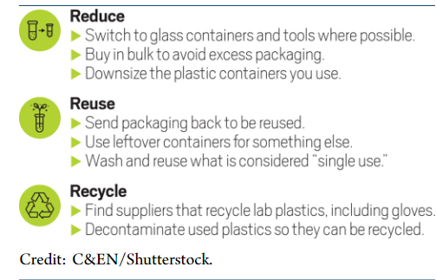
Figure 5. The principles for minimising environmental impacts of plastics in laboratories (Urbina et al., 2015).

5.5 Green transition funding
Some of the above recommendations come with an extra cost. The costs of using glass dishes to replace plastic petri dishes for cell culture are for example around 30 times higher (Urbina et al., 2015). However, other developments, e.g., lighter and more compact petri dishes that save plastic waste, may offer alternatives where the switch to glass petri dishes is not feasible (Reu et al., 2019).

To fund the sustainable lab expenses, external funding may be required. Grant agencies should also be encouraged to introduce incentives to reduce plastic waste. This could for example, include funding new lab washing-up and recycling facilities in applications, and support higher lab costs to fund the transition to sustainable lab equipment instead of the current single use plastic.
This transition will also require the support and information of employees at the station and the larger research institute. A good overview of how scientific workplaces can become more sustainable is given by Durgan et al. (2023).

Monitor plastic use, waste generation, and pollution

Monitoring plastic consumption, waste generation, and emissions to the natural environment is essential for improving station procedures and guidelines, and minimising impacts of plastic use on the natural environment and climate. Furthermore, research stations can play a significant role in assessing general plastic pollution in the area they are located and work with local communities to increase awareness and provide input to local decision makers on the magnitude and trend of plastics in the natural environment.

Monitoring plastic use, waste, and emissions at research stations
Elsewhere in this book, we describe what research stations can do to minimise the use of plastics and reduce emissions to the natural environment. To see whether implemented rules and guidelines are efficient, monitoring of plastic use and waste production is essential. This, together with awareness of new environmentally friendly materials and technologies, will allow research stations to continually work to minimize consumption and improve re-use and recycling options.

Knowledge of plastic types, their different origins, and recycling/biodegradation potentials is important for identifying relevant fractions to monitor, e.g. (See also Figure 3):
  - Fossil origin, Non-recyclable/biodegradable
  - Fossil origin, recyclable/biodegradable
  - Biobased, Non-recyclable/biodegradable
  - Biobased, recyclable/biodegradable

Monitor purchase volumes and waste volumes of waste fractions that are sorted at the station (for each type of plastic waste fraction monitor how much is being reused, sorted for recycling, or sorted for incineration/disposal). Note that when it comes to sorting for recycling purposes, there may be specific requirements for what types can be handled together and which needs to be separated, and there may be requirements of how clean the plastic should be. Contact your waste handling/recycling plant to know what options are available for you.

Use the monitoring information to regularly assess where you can improve policies, rules, and guidelines to minimise the station’s use and emissions of problematic plastics.

Monitoring plastic pollution in the environment
On a global scale there is still much to be done to standardise/harmonise data collection and improve our knowledge on the distribution and effects of plastics in the natural environment. According to Brittany et al. (2020) the scientific community should focus on:
- Development of harmonised protocols and standardisation of data to measure trends over time in a consistent way that is conducive to data sharing.
- Consistent monitoring throughout the year to account for seasonal fluctuations.
- Establishment of baselines from which to measure progress.
- Better data collection from certain parts of the Arctic Ocean region, particularly the Central Arctic Ocean and coastal areas in Siberia, Arctic Alaska, and Canada.
- Increased sampling of snow on ice floes to improve estimates of atmospheric transport of litter.
- Seafloor sediment monitoring since plastics of all sizes accumulate there.
- Identification of “hot spots”—areas of acute contamination with greatest risk to wildlife and the marine ecosystem.
- Improved use of satellite imagery to assess where ice forms and how it moves, thereby providing information about where ice picks up microplastics.
- Further initiatives to develop remote sensing for detecting large debris at sea, as well as sensors to detect plastics in the water column that could be installed opportunistically on vessels.
- Increased collaboration between Arctic communities and scientists in community monitoring of plastic pollution.

Under United Nations Sustainable Development Goal 14 (Conserve and sustainably use the oceans, seas, and marine resources for sustainable development), plastic debris density has been identified as an indicator, including beach litter and microplastics (SDG 14.1.1.b). United Nations Environmental Program (UNEP) is the unit responsible for monitoring this indicator on a global level. UNEP has developed methods for monitoring these key indicators, including methods that can be used by scientists and citizens alike (UNEP, 2021b, United Nations, 2022).

In the Arctic domain, AMAP has published an ecosystem-scale litter and microplastics monitoring plan and associated monitoring guidelines (AMAP, 2021a and 2021b, Provencher et al., 2022). The guidelines provide information of state-of-the-art approaches to monitoring plastics building on information from e.g., UNEP, OSPAR (https://www.ospar.org/), and scientific publications. Focus is on monitoring the distribution of plastics in the environment and document its origin through collaborative science efforts to enable robust plastic pollution assessments and management interventions on Arctic, national, and local levels. Guidelines cover 11 compartments (of which the first four has high priority): Water column, Sediments, Beaches, Birds, Air, Seabed, Invertebrates (both those swimming in the water and those living on the seafloor), Fish, Mammals, Terrestrial soils, and Ice and snow.

Plastics in the environment is a hot scientific topic and although much is happening in the field of plastic monitoring there is still some way to go before a we have a comprehensive understanding of the distribution and effects of plastics in the natural environment. Continued global efforts are needed to build a global monitoring programme and align monitoring methods or harmonize data – but we know enough to say that the problem needs to be addressed already now by individuals, communities, industry, and societies all over the world.

6.2.1 The role of citizen science and community-based monitoring (CBM) in plastic pollution research and monitoring
Effective management of plastic pollution requires actions targeting individual behavioural and societal changes made at decision maker level. Information is key and monitoring programmes can be established with dual purposes of i) documenting the level of pollution, and ii) increasing the awareness of the problem among the general public and decision makers on a local to global scale.

Here citizen science and community-based monitoring may have important roles to play, both to increase geographical coverage of monitoring efforts and for raising awareness that empower people to act. Initiatives involving local communities can be driven by the communities themselves (CBM, Community-Based Monitoring) or be led by a scientist (Citizen Science). One of the benefits of involving local communities is that data can be generated at multiple sites by people living there and often there is a short response time from observation to decision making addressing the problem.

Funding can be a crucial aspect for Citizen Science and CBM efforts to succeed. It depends on the intensions and size of initiatives. In Citizen Science initiatives, volunteers do much of the work, but funding is often needed to pay for leading scientist/coordinator, and possibly for analysis, data handling, report writing and outreach activities. CBM initiatives can be driven by volunteers or led by local NGOs/Governments, of which the latter may require some level of funding. The Government of Canada has e.g., established a dedicated funding scheme, the Indigenous fund for community-based environmental monitoring (https://www.canada.ca/en/environment-climate-change/services/oil-sands-monitoring/community-based-monitoring.html).

Citizen Science
Citizen Science has recently been explored as one way of engaging non-experts in plastic litter research while at the same time, raising awareness and nurturing behavioural changes towards sustainability (Pierini et al., 2021, Popa et al., 2022). Citizen science projects in the context of plastic pollution have spanned from marine plastic litter research (Zettler et al., 2017), plastic pollution in rivers and on streets (e.g., Forrest et al., 2019, Kiessling et al., 2019, 2021, Lynch et al., 2018, Rech et al., 2015), evaluation of household waste and recycling (e.g., Kala et al., 2021, Pierini et al., 2021, Popa et al., 2022), and littering (e.g., Nelms et al., 2022).

In a recent literature review, it became apparent that there are three major plastic research areas in which Citizen Scientists have collaborated with researchers: i) litter distribution, including density and types, ii) recycling of litter, and iii) plastic management practices (Popa et al., 2022). However, there is a clear lack of standardisation regarding data collection for quantification of plastic pollution among studies (Nelms et al., 2022).

The most common citizen science projects that deal with plastic pollution are connected to clean-up initiatives (Nelms et al., 2022). Because of the nature of public involvement in clean-up operations, participants may not necessarily be interested in more detailed assessments, like noting types of plastics or density estimates.

BOX start
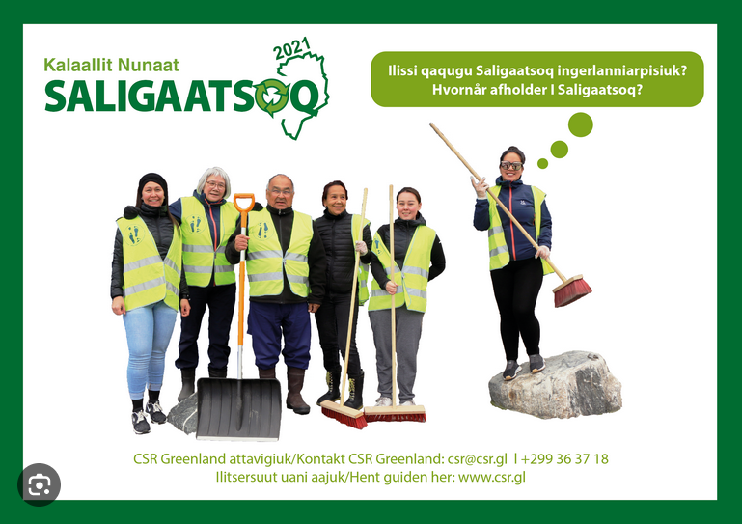
One example seen all over the globe is the organisation of clean-up initiatives that engage local people in collecting plastics, increase awareness and provide local relevant information that is often fed to the decision-making level (Popa et al., 2022).
BOX end

Other challenges (and some solutions) for Citizen Science projects targeting plastic pollution include:
- Data quality:
A common concern is the accuracy of data collected by non-experts, particularly younger participants like school children. However, studies have shown that school children conducted tasks with similar accuracy as untrained professionals (Castagneyrol et al., 2019). Hence, data collected by school children can be valuable as long as researchers are involved in quality checks and thorough training of citizen scientists (Popa et al., 2022).
- Ease of data collection:
Volunteers will be overwhelmed if data collection is clunky and complex. Recent technical advancements, like mobile phone apps, may further accelerate data collection and have the advantage that data can be directly submitted to a database. This reduces the messiness of hard copies and their transcription to a database, which can introduce additional transcriptional errors as well as errors based on readability of original notes. In addition, mobile phones allow for photographs taken at the same time to be submitted alongside data points for additional verification. However, a disadvantage is lack of internet connections in remote regions like the Arctic. Hence, careful consideration of what the best approach may be, is crucial to ensure robust data collection.
- Temporal consistency/loss of interest over time:
Motivation of volunteers may decrease over time, and this may lead to discontinued data collection. Therefore, a strategy for continued communication and engagement needs to be developed. These may include newsletters to the community, lotteries to distribute prices, or similar things. Follow-up meetings in communities to update on the progress of the project is also an important part of these efforts.
EU has produced a report on best practices in Citizen Science for environmental monitoring: https://data.consilium.europa.eu/doc/document/ST-9973-2020-INIT/en/pdf.

Community-based monitoring of plastic pollution
Community-based environmental monitoring (CBEM, Siderova and Virla, 2022, Provencher et al., 2022) can be defined as “a process whereby non-government organisations, community groups, or individuals lead or participate in long-term monitoring of selected species, habitats, or ecosystem processes with the ultimate goal of improving management of ecosystems and natural resources” (Yarnell and Gayton, 2003). In the context of the Arctic, these community-based monitoring projects will often include or be initiated by individuals, NGOs, or local communities that live and work in the respective areas. They often possess valuable knowledge about the local area including local sources of plastic pollution and sinks.

Influence local communities
The INTERACT 7R principles (refrain, replace, reduce, repair, reuse, recycle, react) can be applied to the reduction of plastic waste in individual households and in local communities. This may be particularly relevant in the Arctic where proper waste management systems are rare finds. With few options for proper treatment of plastic waste, engagement and information campaigns targeting local communities may be one way to raise awareness and motivate actions at individual and community levels.

Previous studies have found three main problems related to citizen awareness when it comes to plastic pollution:
- Litter blindness: In several studies, it has been found that people tend to ignore plastic pollution, except if it poses a direct threat to them or is perceived as a nuisance. This leads to an underestimation of the risks linked to plastic pollution. Connected to this is that many rural regions lack proper plastic waste disposal facilities and thus, plastic is inefficiently burned privately (De Veer et al., 2022, Kerber and Kramm, 2022).

- Lack of knowledge: Unawareness on how to sort and recycle different types of plastic, recycling symbols, and how to avoid plastic pollution and reuse of plastics (Popa et al., 2022).

- Underestimation of own contribution to plastic pollution: It has been shown that citizens miscalculate the amount of plastic waste they generate and dispose of (Zikali et al., 2022).
Ways to increase awareness in local communities
- Information sharing targeting specific audiences, e.g.:
  - Posters/brochures on plastic pollution in community centres, malls, museums, churches, etc.: Inform about local/global problem or prepare citizens for clean-up days.
  - Story-telling: Story-telling has been used to increase awareness about marine debris among school children (Praet et al., 2023), but can work for other audiences as well.
  - Lectures or open station events: Inform targeted or general audience about local/global problem.
  - Use of social media: Use and analyses of facebook and X (previously Twitter) posts have found that social media can be an effective way to reach audiences at both local and global levels (Abreo et al., 2021, Otero et al., 2021).

- Citizen science/community-based monitoring projects and clean-up programs (see also chapter 7.5.3):
  - Direct involvement of locals in research-based projects can increase awareness and knowledge on plastic pollution (Locritani et al., 2019, Wichmann et al., 2022).
  - Engagement of scientists in community driven initiatives (e.g., CBM or communal clean-up events).
  - Dedicated clean-up programs with a limited time effort may be suitable for many rural communities whether part of Citizen Science or CBM efforts.
  - Ideally, local authorities should be involved in these efforts to connect citizen observations to the decision-making level and facilitate the development of plastic management systems that is locally relevant and accepted by the community (which will likely result in higher adherence rates).
  - Finally, collaborative development of easy-to-understand guidelines and campaigns to reach the wider community is important to bridge the gap between knowledge/decision making and implementation/action.

A future outlook
With the predicted increase in plastic production and increased volumes of plastics ending up in the natural environment, the global society faces significant challenges. We cannot remove all plastics from the environment, so we need to stop it from getting there. The scientific community must act to reduce its own consumption and waste generation, but also seek to document the scale of the problem and understand environmental and human health effects. Societies and industries should take responsibilities for developing a legal framework for minimising plastics in the environment and its health effects on humans. We need to develop sustainable alternatives to plastic and develop a circular economy for the plastics that we need. We need both societies, science, industry, and individuals to take action by following the INTERACT 7R principles (refrain, replace, reduce, repair, reuse, recycle, react) and seek to influence family, friends, colleagues, workplaces and politicians.

No easy way of removing micro- and nanoplastics from the environment
Due to their size and ubiquity, there are currently no cost-efficient mechanisms to collect microplastics from the environment at large scale once they have been introduced to it. Therefore, the most efficient way to mitigate microplastic pollution is to prevent microplastics from entering the environment in the first place and by targeting actions to reduce emissions at the source.
The market today offers an array of alternative plastic-free products, and the options are increasing. From lipsticks free of microplastic or brushes made of wood to t-shirts made of natural fabrics.

A sea of unknown health and environmental effects
Some plastic types contain chemicals with known negative effects on the natural environment and human health, and there is also mounting evidence of the physical effects on wildlife. Our knowledge of the long-term effects of plastic particles found in the environment is less well understood and more research into sources, sinks, and effects of different types of plastic is needed.

Alternatives to plastics
When considering alternatives to plastics, it is important to consider climate and environmental impacts of the entire lifecycle of the materials: extraction, production, transport, use, reuse, recycling, treatment, emissions to the natural environment and its’ impacts on society, landscape, environment, and species. Finding alternatives to common items like plastic bottles and plastic packaging is becoming increasingly easier. Examples include replacement of microspheres and microfibres in building paint with either glass beads or cellulose-based microspheres; or replacing microplastics used in industrial abrasives with coconut shell, dry ice, silicon, or glass beads. Sustainable alternatives must be developed and used at a significant scale to decrease the production and waste of plastics and other so-called "environmentally friendly" materials, because the increasing plastic production show a need for these types of materials.

Circular economy and waste as a resource
Eliminating plastic waste relies, in part, on changing behaviour. To eliminate plastic waste requires wide-scale system changes and a shift from a linear to a circular plastics economy (Figure 5), where plastic is flowing around in a ’closed loop’ system and where products are re-used, re-purposed, recycled, and recovered (Allison et al., 2022).

In a circular economy, materials are designed to be used, reused, and recycled, not to end up in landfills or the environment. No materials are lost, no toxins are leaked. All the plastic items we use should be circulated to keep them in the economy and we should avoid losing any of it to the environment. A shift from a linear to a circular plastics economy means a system that keeps plastics in a ’closed loop’ system where products are re-used, re-purposed, and recycled (Figure 7).

Ultimately, preventing plastic waste in the first place is the key to a cleaner, healthier environment.

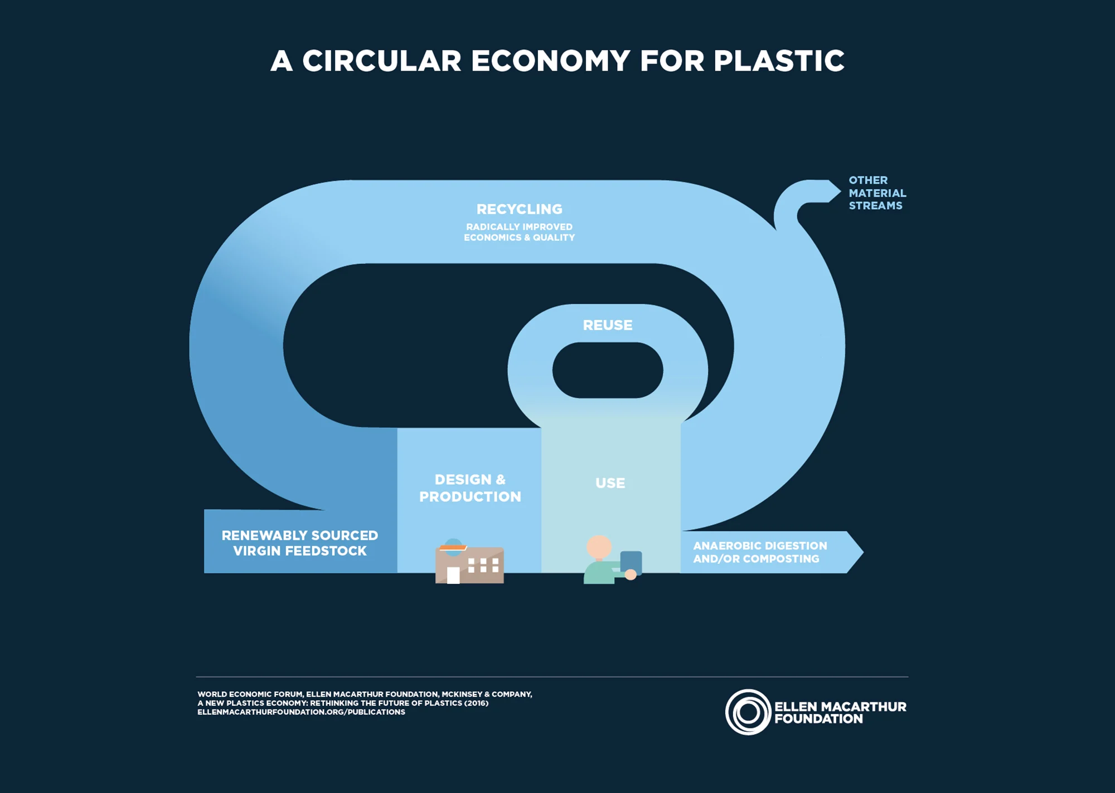
Figure 7. Envisaged circular economy for plastics (https://ellenmacarthurfoundation.org/plastics-and-the-circular-economy-deep-dive) – Layouter to redraw.

3D printing and energy generation from plastic waste
Another recent development is to recycle lab plastics for 3D printing or energy generation (https://experiment.com/projects/reducing-scientific-research-waste-production-can-we-recycle-lab-plastics-for-3d-printing). In the case of 3D printing, the idea is to collect plastic waste in the lab and then use 3D printers to generate new plasticware that can be used in the laboratory or elsewhere in the organisation.

Sahu et al. (2021) proposed a system to use laboratory plastic waste for energy harvesting by generation of stable and cost-effective triboelectric nanogenerator (TENG) mechanisms for sustainable powering of low-power electronics. It has been also proposed to use 3D printing with marine plastic waste to build products for the marine industry in a circular economy framework (Cañado et al., 2022, Maldonado-García et al., 2021). To conclude, it appears that different scalable solution related to 3D printing are being developed and these may reduce plastic waste in the future at scientific stations and maybe, local communities alike.

References
Abreo, N.A.S.; Thompson, K.F.; Arabejo, G.F.P. and Superio, M.D.A. (2019). Social Media as a Novel Source of Data on the Impact of Marine Litter on Megafauna: The Philippines as a Case Study. Marine Pollution Bulletin, 140, 51–59.

Aguilar, P.V. (2018). Challenges to Solve Our Plastic Waste Problems. International Journal of Organic & Medicinal Chemistry (2474-7610).
https://juniperpublishers.com/omcij/pdf/OMCIJ.MS.ID.555713.pdf

Allison, A.L. et al. (2022). Reducing plastic waste: a meta-analysis of influences on behaviour and interventions. Journal of Cleaner Production, 380. 134860. ISSN 0959-6526

AMAP (2021a). AMAP Litter and Microplastics Monitoring Plan. Arctic Monitoring
and Assessment Programme (AMAP), Tromsø, Norway, 23pp.
https://www.amap.no/documents/download/6713/inline

AMAP (2021b). AMAP Litter and Microplastics Monitoring Guidelines. Version 1.0. Arctic Monitoring
and Assessment Programme (AMAP), Tromsø, Norway, 257pp. https://www.amap.no/documents/download/6761/inline

Barth, T. (2021, October 2). Making Menstruation Products Eco Friendly. Plastics Oceans
International.
https://plasticoceans.org/making-menstruation-products-eco-friendly/

Bioplastics Europe - https://bioplasticseurope.eu/about (accessed June 12, 2023)

Boucher, J. and Friot, D. (2017). Primary Microplastics in the Oceans: A Global Evaluation of Sources. Gland, Switzerland: IUCN. 43pp.

Bergmann, M. et al. (2022). Plastic pollution in the Arctic. Nature Reviews Earth & Environment, 3, 323–33. https://doi.org/10.1038/s43017-022-00279-8

Cabrera, A. and Garcia, R. (2019). The environmental and economic costs of single-use menstrual
products, baby nappies and wet wipes.
https://zerowasteeurope.eu/wp-content/uploads/2019/12/bffp_single_use_menstrual_products_baby_nappies_and_wet_wipes.pdf

Cañado, N.; Lizundia, E.; Akizu‐Gardoki, O.; Minguez, R.; Lekube, B.; Arrillaga, A. and Iturrondobeitia, M. (2022). 3D printing to enable the reuse of marine plastic waste with reduced environmental impacts. Journal of Industrial Ecology, 26(6), 2092-2107.

Castagneyrol, B. et al. (2019). Can school children support ecological research? Lessons from the ‘Oak bodyguard’ citizen science project. bioRxiv, 712638.
https://theoryandpractice.citizenscienceassociation.org/articles/10.5334/cstp.267

Cózar, A. et al. (2017). The Arctic Ocean as a dead end for floating plastics in the North Atlantic branch of the Thermohaline Circulation. Scientific Advances, 3: e1600582

Davidson, M.G.; Furlong, R.A. and McManus, M.C. (2021). Developments in the life cycle assessment of chemical recycling of plastic waste – A review. Journal of Cleaner Production, 293, [126163]. https://doi.org/10.1016/j.jclepro.2021.126163

De Veer, D. et al. (2022). How Do Schoolchildren Perceive Litter? Overlooked in Urban but Not in Natural Environments. Journal of Environmental Psychology, 81, 101781.

Durgan, J.; Rodríguez‐Martínez, M. and Rouse, B. (2023). Green Labs–a guide to developing sustainable science in your organisation. Immunology and Cell Biology.
https://doi.org/10.1111/imcb.12624

Eriksen, M. et al. (2020). Mitigation strategies to reverse the rising trend of plastics in Polar Regions. Environment International, Volume 139, 2020, 105704, ISSN 0160-4120. https://doi.org/10.1016/j.envint.2020.105704

Flint, S. et al. (2012). Bisphenol A exposure, effects, and policy: A wildlife perspective.
Journal of Environmental Management, Volume 104, pp 19-34. ISSN 0301-4797.

Forrest, S.A.; Holman, L.; Murphy, M. and Vermaire, J. C. (2019). Citizen science sampling programs as a technique for monitoring microplastic pollution: results, lessons learned and recommendations for working with volunteers for monitoring plastic pollution in freshwater ecosystems. Environmental Monitoring and Assessment, 191, 1-10.

Geilfus, N.X.; Munson, K.M.; Sousa, J.; Germanov, Y.; Bhugaloo, S.; Babb, D. and Wang, F. (2019). Distribution and impacts of microplastic incorporation within sea ice. Marine Pollution Bulletin, 145, 463-473.

Geyer et al. (2017). Production, use, and fate of all plastics ever made. Scientific Advances, 3 ,e1700782. https://doi.org/10.1126/sciadv.1700782

Hamilton, B.M.; Baak, J. E.; Vorkamp, K.; Hammer, S.; Granberg, M.; Herzke, D. and Provencher, J. F. (2022). Plastics as a carrier of chemical additives to the Arctic: possibilities for strategic monitoring across the circumpolar North. Arctic Science.
https://doi.org/10.1139/as-2021-0055

Kala, K. and Bolia, N.B. (2021). Analysis of Citizen’s Perception towards Segregation and Composting. Environment, Development and Sustainability, 23, 10763–10786.

Kerber, H. and Kramm, J. (2022). From Laissez-Faire to Action? Exploring Perceptions of Plastic Pollution and Impetus for Action, Insights from Phu Quoc Island. Marine Policy, 137, 104924.

Kiessling, T.; Knickmeier, K.; Kruse, K.; Brennecke, D.; Nauendorf, A. and Thiel, M. (2019). Plastic Pirates Sample Litter at Rivers in Germany—Riverside Litter and Litter Sources Estimated by Schoolchildren. Environmental Pollution, 245, 545–557.

Kiessling, T. et al. (2021). Schoolchildren Discover Hotspots of Floating Plastic Litter in Rivers Using a Large-Scale Collaborative Approach. Science of the Total Environment, 789, 147849.

Kilcoyne, J.; Bogan, Y.; Duffy, C. and Hollowell, T. (2022). Reducing environmental impacts of marine biotoxin monitoring: A laboratory report. PLOS Sustainability and Transformation, 1(3): e0000001. https://doi.org/10.1371/journal.pstr.0000001

Koelmans, A.A. et al. (2022). Risk assessment of microplastic particles. Nature Reviews Materials. 7, 138–152.

Koelmans, A.A.; Besseling, E. and Shim, W.J. (2015). Nanoplastics in the Aquatic Environment. Critical Review. In: Bergmann, M., Gutow, L., Klages, M. (eds.), Marine Anthropogenic Litter. Springer.

Linnebjerg, J. et al. (2021). Review of plastic pollution policies of Arctic countries in relation to seabirds. Conservation of Arctic Flora and Fauna International Secretariat: Akureyri, Iceland. ISBN 978-9935-431-89-9.

Locritani, M.; Merlino, S. and Abbate, M. (2019). Assessing the Citizen Science Approach as Tool to Increase Awareness on the Marine Litter Problem. Marine Pollution Bulletin, 140, 320–329.

Lynch, S. (2018). OpenLitterMap.Com—Open Data on Plastic Pollution with Blockchain Rewards (Littercoin). Open Geospatial Data, Software and Standards, 3, 6.

Maldonado-García, B.; Pal, A. K.; Misra, M.; Gregori, S. and Mohanty, A.K. (2021). Sustainable 3D printed composites from recycled ocean plastics and pyrolyzed soy-hulls: Optimization of printing parameters, performance studies and prototypes development. Composites Part C: Open Access, 6, 100197.

Mishra, S. et al. (2019). Marine microfibre pollution: A review on present status and future challenges. Marine Pollution Bulletin, Volume 140, 2019, Pages 188-197.

Müller, C. (2021). Not as Bad as It Seems? A Literature Review on the Case of Microplastic Uptake in Fish. Frontiers in Marine Science, 8:672768.
https://doi.org/10.3389/fmars.2021.672768

Nelms, S.E. et al. (2022). The role of citizen science in addressing plastic pollution: Challenges and opportunities. Environmental Science and Policy, 128, pp 14-23.

Norsk Vann, 2021

OECD (2023a). Plastic leakage and greenhouse gas emissions are increasing - OECD (accessed last time on June 15, 2023)

OECD (2023). https://www.oecd.org/newsroom/plastic-pollution-is-growing-relentlessly-as-waste-management-and-recycling-fall-short.htm (accessed last time on April 27, 2023)

Otero, P.; Gago, J. and Quintas, P. (2021).Twitter Data Analysis to Assess the Interest of Citizens on the Impact of Marine Plastic Pollution. Marine Pollution Bulletin, 170, 112620.

Pierini, V.I.; Mazzeo, N.; Cazenave, M. and Semmartin, M. (2021). Waste Generation and Pro-Environmental Behaviors at Household Level: A Citizen Science Study in Buenos Aires (Argentina). Resources Conservation and Recycling,, 170, 105560.

Popa, C.L., Dontu, S.I., Savastru, D. and Carstea, E.M. (2022). Role of Citizen Scientists in Environmental Plastic Litter Research—A Systematic Review. Sustainability, 14(20), 13265.

Praet, E. et al. (2023). Bottle with a message: The role of story writing as an engagement tool to explore children's perceptions of marine plastic litter. Marine Pollution Bulletin, 186, 114457.

Provencher, J.F. et al. (2022). Future monitoring of litter and microplastics in the Arctic—challenges, opportunities, and strategies. Arctic Science.
https://doi.org/10.1139/as-2022-0011

Rech, S.; Macaya-Caquilpán, V.; Pantoja, J.F.; Rivadeneira, M.M.; Campodónico, C.K. and Thiel, M. (2015). Sampling of Riverine Litter with Citizen Scientists—Findings and Recommendations. Environmental Monitoring and Assessment, 187, 335.

Reu, P.; Svedberg, G.; Hässler, L.; Möller, B.; Andersson Svahn, H. and Gantelius, J. (2019). A 61% lighter cell culture dish to reduce plastic waste. Plos one, 14(4), e0216251.

Rist, S. et al. (2018). A critical perspective on early communications concerning human health aspects of microplastics. Science of the Total Environment, Volume 626, 2018, pp 720-726.

Ross, P.S. et al. (2021). Pervasive distribution of polyester fibres in the Arctic Ocean is driven by Atlantic inputs. Nature communications, 12(1), 106.

Rosenboom JG, Langer R, Traverso G. Bioplastics for a circular economy. Nat Rev Mater. 2022;7(2):117-137. doi: 10.1038/s41578-021-00407-8. Epub 2022 Jan 20. PMID: 35075395; PMCID: PMC8771173.

Royer, S.-J.; Ferro´n, S.; Wilson, S.T. and Karl, D.M. (2018). Production of methane and ethylene from plastic in the environment. PLoS ONE 13(8): e0200574.
https://doi.org/10.1371/journal. pone.0200574

Sahu, M.; Hajra, S.; Kim, H.G.; Rubahn, H.G.; Mishra, Y.K. and Kim, H.J. (2021). Additive manufacturing-based recycling of laboratory waste into energy harvesting device for self-powered applications. Nano Energy, 88, 106255.

SAPEA, Science Advice for Policy by European Academies. (2019). A Scientific Perspective on Microplastics
in Nature and Society. Berlin: SAPEA.
https://doi.org/10.26356/microplastics

Sidorova, J. and Virla, L.D. (2022). Community-Based Environmental Monitoring (CBEM) for Meaningful Incorporation of Indigenous and Local Knowledge Within the Context of the Canadian Northern Corridor Program. The School of Public Policy Publications, 15(1).

Snekkevik, V.K.; Chakravorty, D.; Falk-Andersson, J. and Fürst, K. (2023). Miljøvennlige menstruasjonsprodukter i Osloskolene. NIVA-rapport.
https://niva.brage.unit.no/niva-xmlui/handle/11250/3050789

United Nations Environment Programme (2021a). Single-use menstrual products and their alternatives: Recommendations from Life Cycle Assessments. https://www.lifecycleinitiative.org/wp-content/uploads/2021/07/UNEP-LCISingle-use-vs-reusable-Menstrual-Products-Meta-study.pdf

United Nations Environment Programme (2021b). Understanding the State of the Ocean: A Global Manual on Measuring SDG 14.1.1, SDG 14.2.1 and SDG 14.5.1. Nairobi
https://wedocs.unep.org/handle/20.500.11822/35086

United Nations (2022) SDG indicators, metadata repository. Available at: https://unstats.un.org/sdgs/metadata/ (Accessed November 21, 2022)

Urbina, M.; Watts, A. and Reardon, E. (2015). Labs should cut plastic waste too. Nature 528, 479. https://doi.org/10.1038/528479c

Walker, T.R. (2022). Communicating Threats and Potential Opportunities to Reduce Microplastic Pollution with Key Stakeholders. Microplastics, 1(2), pp 319-321.

Wichmann, C.S. et al. (2022). Promoting pro-environmental behavior through citizen science? A case study with Chilean schoolchildren on marine plastic pollution. Marine Policy, 141, 105035.

World Economic Forum (2016). The New Plastics Economy. Rethinking the future of plastics. Report downloaded from: The New Plastics Economy: Rethinking the future of plastics | World Economic Forum (weforum.org), April 2023.

Yarnell, P. (2003). Community-based ecosystem monitoring in British Columbia. désLibris – Canadian Electronic Library.

Zettler, E.R.; Takada, H.; Monteleone, B.; Mallos, N.; Eriksen, M. and Amaral-Zettler, L.A. (2017). Incorporating Citizen Science to Study Plastics in the Environment. Analytical Methods, 9, pp 1392–1403.

Zikali, N.M.; Chingoto, R.M.; Utete, B. and Kunedzimwe, F. (2022). Household Solid Waste Handling Practices and Recycling Value for Integrated SolidWaste Management in a Developing City in Zimbabwe. Scientific African, 16, e01150.

