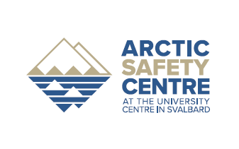

Arctic field Safety course

Objective
The course participants must be able to identify and limit the risks of activities carried out at a research station. In addition, they must describe actions that prevent or restrict the impact of incidents and accidents associated with the station's activities.
This is a pilot course; therefore, participants must contribute to design the final course.

Participants
The course is primarily aimed at persons who are responsible for the day-to-day operation of a research station. The course may also be relevant to persons who are responsible for implementing major field activities.

Prerequisites
It is expected; that participants have knowledge of arctic conditions and have knowledge of the general operation of a research station or for the implementation of major field activities.

Duration:
The course starts Monday 1 October at 04PM and ends Monday 8 October at 11AM (on arrival by plane from Ny-Ålesund).

Program
The course is structured as a combination of theory and practice, why accommodation in the field will be a major part of the course.

Monday at 16 - 22:
Welcome and introduction to the course.
Risk analysis; theory and method
Case: Stay outside the research station
Preparation for field stays

Tuesday - Thursday:
Sailing to Trygghamna, where we establish our camp
Setting up camp
• Layout for a camp
• Securing the camp
• Use of rifle and flare gun
Review of natural hazards such as:
• Terrain types, landslide and avalanches, river, open water, snow as well as ice and glaciers
• Climate and weather
• Wild Life
Trip Planner:
• Security procedures (roles and responsibilities)
• Tour preparation, summer and winter
• Dressing, summer and winter
• Emergency equipment
Sailing with Polarsyssel to Ny-Ålesund
• Use of small boats
• Safety equipment and clothing
• Work from larger vessels

Friday - Sunday:
Arrival in Ny-Ålesund Research Station
Introduction to Ny-Ålesund Research Station and the activities carried out from different bases

Review of manmade risk factors:
• Transport by snowmobile, ATV, helicopter and airplane
• Work on glaciers and sea ice
• Testing of maritime emergency equipment

Communication and Navigation:
• Communication means, HF, VHF, satellite phone, PLB
• Navigation means, card and compass, GPS

Environmental pollution:
• Spills and waste
• Ancient monuments

Crisis management:
• Emergency plan
• SAR handling, equipment, procedures
• Accident management, information and communications, roles and responsibility
• Fire preparedness, evacuation plans
• Debriefing

Sunday evening:
Course evaluation

Monday morning:
Flight back to Longyearbyen

